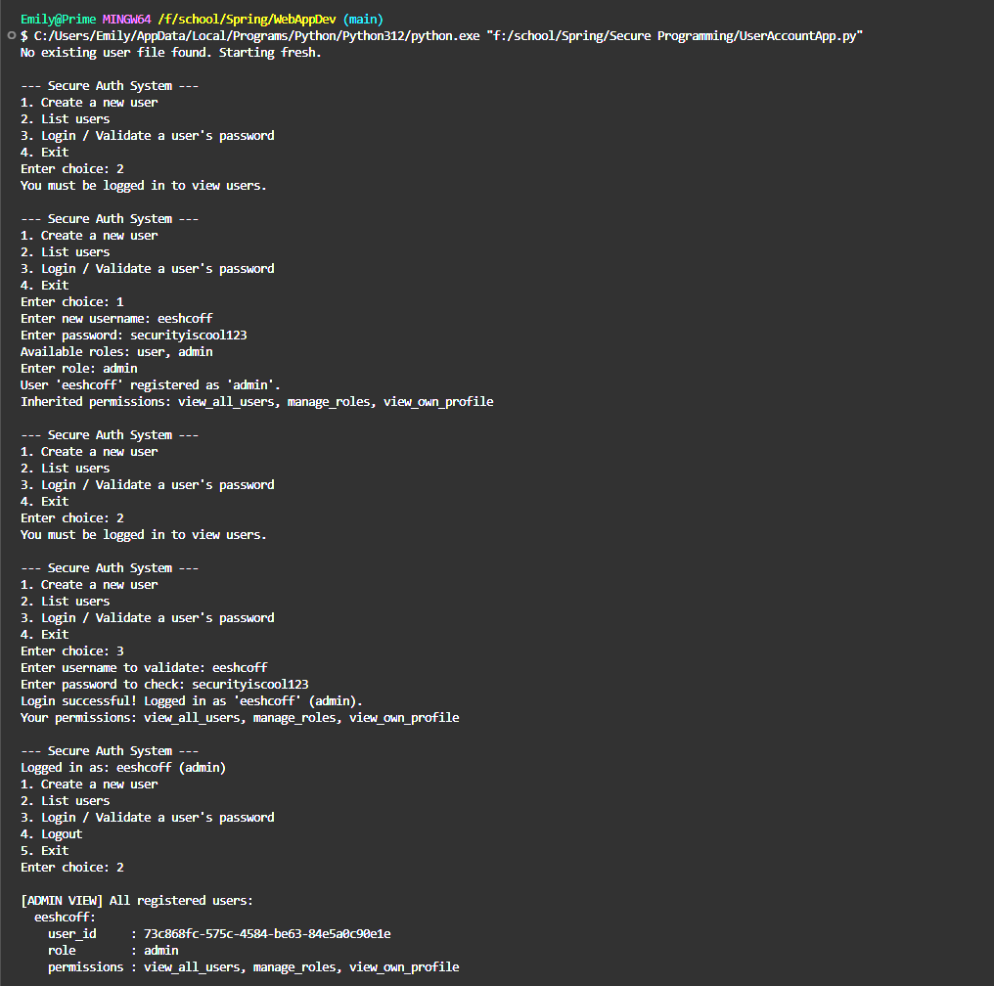

Console shows the running updated program using uuid protocols instead of salt for the user id and password security.
initial tests above show the program’s ability to register a new user and set them as admin, and that their permissions are able to allow them to see their own profile after creation.

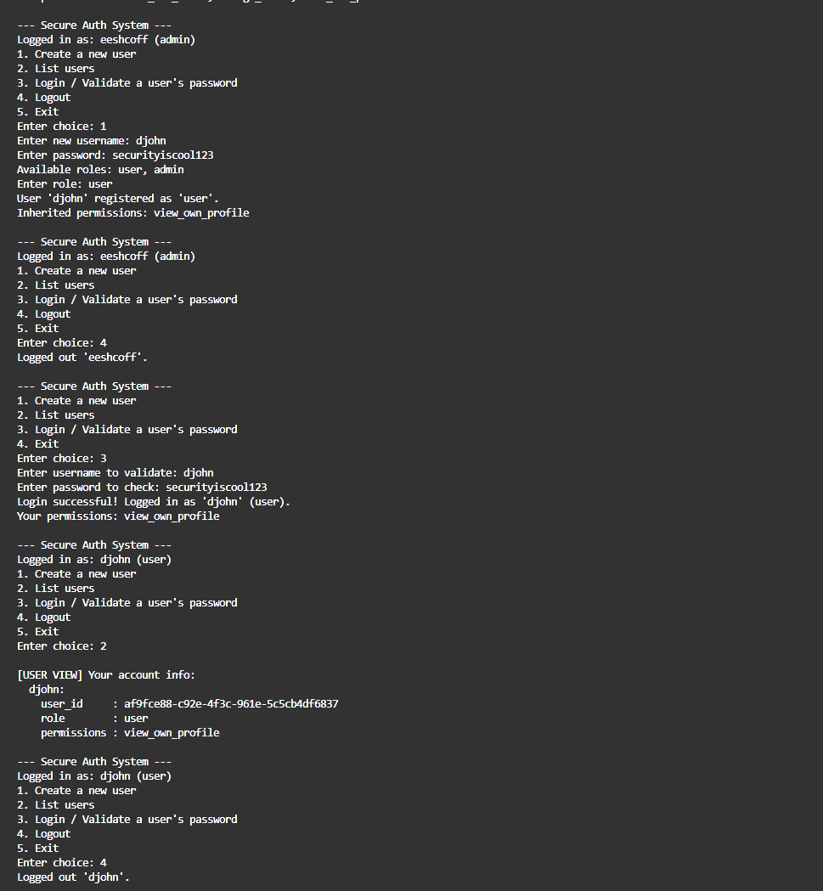

This section displays the testing of how the admin is able to logout, and a new user is able to create their own profile as a user, and testing shows them able to only see their own profile despite an existing admin account also in the program, thus the permissions work.

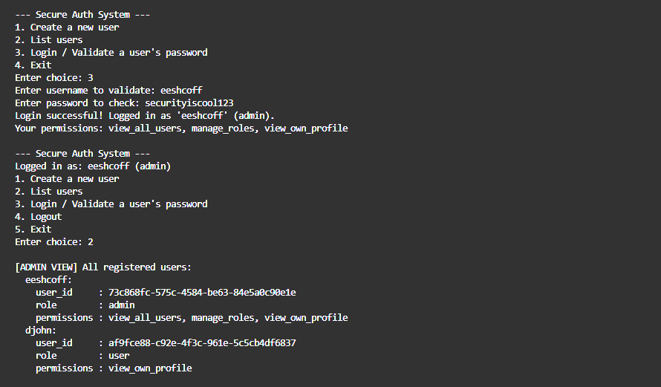

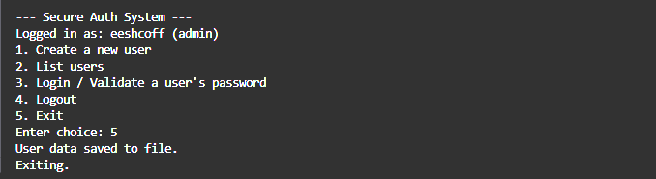
returning to the admin account user, permissions allow them to be able to see the user information for both existing accounts with both roles assigned to each respective account.

Final logout and exiting of the program works as intended.

